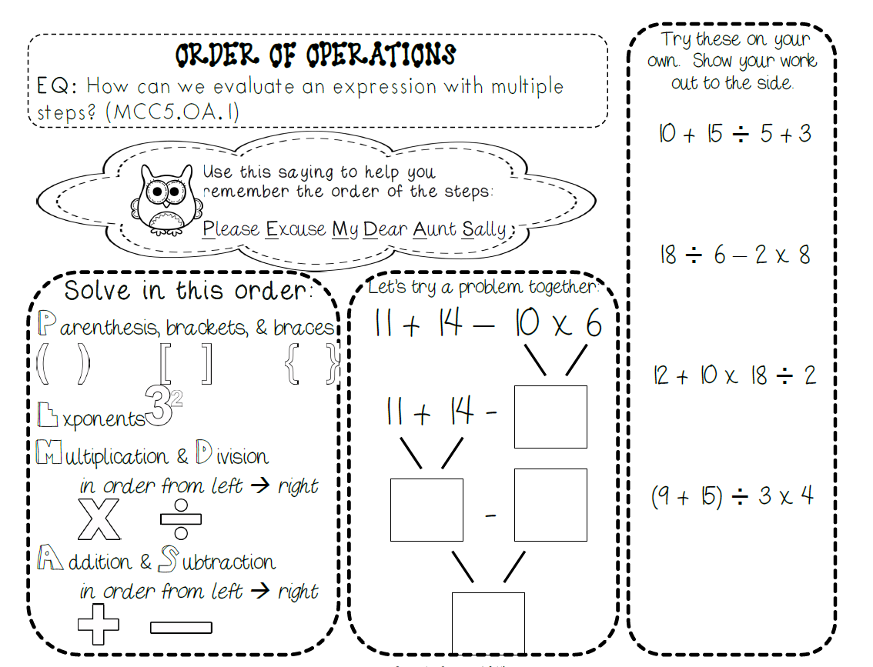
Always start with the innermost symbol. If you have parentheses work the problems in the parentheses first. Then move to the brackets and work everything in the brackets. Lastly, make sure you have worked everything in the braces.
- What is the first step to complete in solving this expression?
2 { 3 + [ 3 ( 4 +2) + 2 ] }

- Add 4 + 2
- Multiply 3 by 2
- Multiply 3 and 6
- Add 3 and 3

- What is the first step to complete in solving this expression
3 [(30-2) ÷ 2 ] + 9

- Multiply 2 and 9
- Divide 2 and 9
- Subtract 2 from 30
- Divide 2 by 30

- Look at the expression: What is the solution to the expression?
10 + (10x4) – 5=
- 40
- 45
- 30
- 55

- Solve: Remember when you have a number outside of the parentheses, brace, or bracket you will multiply that to the answer that you get on the inside of the parentheses, bracket, braces unless there is another operation specified
2 { 3 + [ 3 ( 4 +2) + 2 ] }

- 16
- 40
- 16
- 8

The correct answers are the ones on bold print. Please visit Study Island to practice more skills related to solving expressions with the order of operations.

There is a video linked to our math page on our class website that you can view for additional support.

