C:\Documents and Settings\Vanessa Norman\Local Settings\Temporary Internet Files\Content.IE5\MJDAY5MX\MCj03320280000[1].wmf

Immigrant Suitcase

* Create a suitcase/treasure box that holds the memories of an immigrants past, arduous (strenuous) journey, and life in America. This project will help you explore reasons for immigration in the 1920’s, the struggles of an immigrant family, the experiences from an immigrant’s perspective, and the historical trends that have occurred.
* Put yourself in the shoes of an immigrant child your age who came to America in the late 1800’s or early 1900’s. You will create a suitcase that reflects the thoughts, feelings, and experiences of this child. (You might want to research where your family came from, reasons for emigrating from that country, what they did once they arrived in the new land.) This project will require significant research. You should do most of your research before you start on the suitcase.
* This suitcase can be an actual suitcase, a copy paper box, a duffel bag, a brown paper bag, a small trunk, or a small box or shoebox with a lid. Decorate the box with paper, mementoes, trinkets, etc. The suitcase cover should include the immigrant’s name, your name, and an illustration. The illustration can be a “photo” of the immigrant, a landmark or image from the immigrant’s country of origin, an American symbol, or some other image of your choice. Inside your suitcase/treasure box you will place the items listed below:

**FAMILY PHOTO**- You may draw a large “photograph” of the immigrant’s family. Use a pencil to simulate the black and white photography of the day. You may also scan a current picture of your family and print it off in black and white, possibly using Photoshop to insert a landmark from your country of origin. Write a list of the vital statistics of each family member (name, age, occupation) next to the photograph.

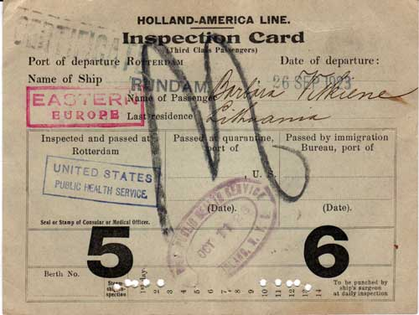**ELLIS ISLAND INSPECTION PAPERS**- Create a document issued to the immigrant at Ellis Island for both medical and legal exams. The legal document should include the immigrant’s name, age, sex/gender, occupation, marital status, nationality, last residence, point of departure, destination, date of departure, date of arrival, who paid for the voyage, how much money you had, criminal record, names of relatives in the U.S., and whether or not you had a job waiting for you in the U.S. Research the types of medical conditions screened for at Ellis Island. You will need family documentation of your medical check.

**DIARY ENTRIES**- Write at least 4 diary entries that describe the immigrant’s feelings on the night before his or her journey to America. It should be written in the first person and include the reason the family is emigrating from their homeland, the “date” on which the diary entry was written, and information about the diarist. Below are some suggestions of things to include in your entries:

* Who are your family members? How old is each person? What are your names? What are their trades or occupations?
* What country have you come from? Draw your country’s flag. Find and label your country on the map of Europe. What money (currency) do you use? What foods do you eat? What language do you speak?
* Why is your family leaving their homeland behind and risking so much to live in this new country?
* Describe your experience on the ship. How long was your journey? What were the conditions like?
* What prized possessions did each of you bring? Why did you choose to take those things with you?
* Describe each of your emotions when you first saw America and “Lady Liberty.”
* Describe your experience going through immigration. Did you go through Ellis Island? What inspections did each of you have to go through? What types of problems did each of you face?
* Where will your family live?
* Describe how your life will be different in America. How will you communicate with other people? What food will you eat? What money will us use and for what?
* Think about all you have been through to risk coming to this country. Explain your feelings and thoughts.

**PHOTOGRAPHS**- Four photographs should be scattered throughout the suitcase. Captions should be written that describe each of the photos. Ideas for the pictures include, but are not limited to the following:

* A major landmark or sight from the immigrant’s country of origin
* The most difficult part of the immigrant’s journey on the ship to America
* An event that happened to the immigrant at Ellis Island
* A scene from the immigrant’s life in America

**OPTIONAL ITEMS (Pick One) you may include more than one if you wish:**

**LETTER TO A FRIEND BACK** **HOME**- Write a letter from the immigrant child to a friend in his or her homeland. The letter should describe the immigrant’s emotions when he or she first saw America, the family’s housing situation, where the parents work, where he or she goes to school or works, any challenges they face, how life is different in the new country, and so forth. Put the letter in an envelope, address it, and include inside your suitcase.

**SOUVENIRS AND MEMENTOS**- Create, collect, or find at least six souvenirs that the immigrant child would have put in their suitcase. These objects should reflect events in the child’s life and journey.

**OPTIONAL ITEMS**-Any of the following choices need to depict an immigrants experience. These might include: the front page of the newspaper from your country or Ellis Island, a diary, money, the literacy test an immigrant 16 years or older was given at Ellis Island, an add for a job you might seek, the ticket you purchased for your voyage, a family tree, etc. These are just a few suggestions. You may get additional choices approved through your teacher.

**WEBSITES YOU MAY WANT TO USE**:

* PASSENGER LIST and IMMIGRANT STORIES

[http://www.ellisisland.org/](http://www.ellisisland.org/%20%20)

1. click on “Ellis Island” and go down to “Immigrant Experience”

2. click on family histories and read the six stories of immigration (especially Byron Yee’s)

3. Also under the “Immigrant Experience” tab is “the peopling of America” – click on the time period to learn more about immigration during that time

* NATIONAL PARK SERVICE with pictures and stories of immigration

http://www.nps.gov/archive/stli/serv02.htm

* SCHOLASTIC’S IMMIGRATION WEBSITE FOR KIDS

http://teacher.scholastic.com/activities/immigration/index.htm

1. Read about Seymour Rechtzeit’s life as an immigrant. You will need to click the blue tabs on the left to follow his story. When you click on the “Ellis Island” tab, be sure to take the interactive tour.
2. Also click on “Explore Immigration” for further information.