Week of September 19th, 2016- Please see the optional flipped homework for math, science, and social studies below. If you have any questions please feel free to ask. This is due on Friday September 23rd.
Math - Review the following math videos from Kahn Academy. After watching the videos create a poster demonstrating how to add, subtract, and round decimals using one of the methods you learned in the videos.
https://www.khanacademy.org/math/pre-algebra/pre-algebra-decimals/pre-algebra-rounding-decimals/v/rounding-decimals
https://www.khanacademy.org/math/pre-algebra/pre-algebra-decimals/pre-algebra-add-decimals/v/adding-decimals-example-1
https://www.khanacademy.org/math/arithmetic-home/arith-review-decimals/sub-decimals-sa/v/subtracting-decimals
Science- Constructive and Destructive Forces: Visit the following website and play the review game each night. Have your parent’s sign that you played and record your score in the chart below.
Monday- | Tuesday- | Wednesday- | Thursday- | Friday-
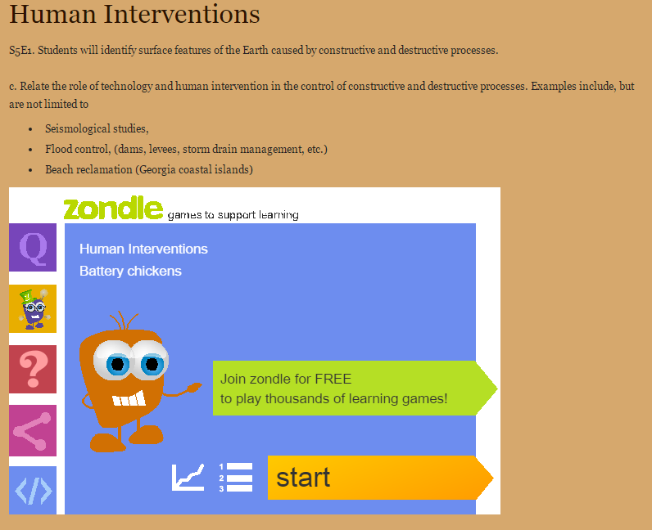
Social Studies - Watch
During this week for Flipped homework you will visit the following website http://www.jonathanfeicht.com/civil-war-interactive-timeline.html and review major events of the Civil War. After you have reviewed the material create a timeline of your own on a poster paper. Make sure to be creative with your timeline by adding pictures and descriptions. The videos on the site will help you add important details to your poster.

